**Introduction:**

**Purpose of the Project**: What is the relationship between weather conditions and the quality of football matches in premier league.

As it is known that football is world’s most popular ball game in number of participants and spectators Originally it is a British creation sports kind.This is the main reason why premier league is the best place to watch football all around the world. UK is one of the world’s premier tourist destination and all come for watching premier league.Figures from Visit Britain show that football is significant contributor to inbound tourism to Britain(quote:http://www.telegraph.co.uk/investing/business-of-sport/power-of-football/) .As it is known that football is an industry also, premier league and its clubs have an enormous budget by force of the incredible number of spectators and audiences all over the world.By the effect of significant budget, spectator support and being the place where football is invented, the brand value of premier league in comparison to the all other football leagues is much more.There is an incredible competition among the clubs and also fans of the clubs.With the hepl of high economic status of Premier League clubs, they can fund and so transfer the most high-priced footballers to Britannia.That is why we investigated Premier League instead of other leagues.

The affect of weather conditions on sports played with balls outdoor can not be underestimated most of the times.Football is one of that outdoor sports and weather conditions ofcourse affect the quality of the match.For instance if weather condition is heavy rained, the quality of football comes down significantly of if the weather is sunny, it also may affect the concentration of the players.It is generally known that moderate rain affects football matches positively. Roughly speaking the weather’s being cloudy or non-cloudy does not have an affect on the match unless it is windy.Wind speed and also the direction of the wind should be an important parameter for the home team or away team.

Because of those reason, we associated weather conditions with premier league.

**Data Sources:**

We have used 3 different data sources for the project.Two of the sources are data for the 2015/2016 season of premier league and one is for weather.

1. For weather conditions,we have used world weatheronline api,here is the URL of the source: **“**[**https://developer.worldweatheronline.com/api/docs/historical-weather-api.aspx**](https://developer.worldweatheronline.com/api/docs/historical-weather-api.aspx)**”**

We have used this api for free historical data instead of OpenWeatherMap.org .How did we access data ? We used URL for accessing data.An example of a URL for this source:

<http://api.worldweatheronline.com/premium/v1/past-weather.ashx?key=24b9d00f85024f28bab155827161011&q=Chile&format=json&date=2010-04-21&showmap=yes&APPID=24b9d00f85024f28bab155827161011>

Using this URL we accesed a json file and processed that json file.By editing the related parts of the URL and attaching the api key that this source provides us at the end of the URL,we obtained necessary parts and related data.This web channel also supplies to users an interactive API explorer and displays response via that explorer to observe the data that will be uploaded.

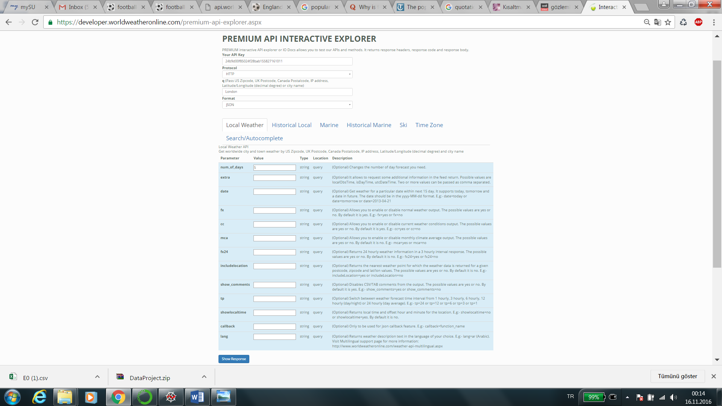

This is the picture of the interactive api explorer.Users can login too many detailed parameter about the weather condition of the related time it responses so much detailed explanation such as end date,max temp min temp,hourly weather status of the selected date,sunset,moonrise,wind degree ,wind speed and so on.

1. For the other data source of premier league, we used this web site. <http://www.football-data.co.uk/englandm.php> . This source gives us all of the detailed statistics(number of corners, away team shots,home team shots, shots on targeted for home and away teams also,etc) of eachmatch inside a csv file.This source includes too many historical data about previous seasons and match statistics including premier league seasons.Each record has those statistics excluding the time of the match and that is why we needed “api.football-data.org” .We matched the records of that file by the records of the other file and combined the values of the data to obtain detailed information including time ,date and match statistics.

3)The second footbal data source that we have used is : “http://api.football-data.org/index” This source provides data about the match record that we have obtained from “football-data.co”.This source gives some match statistics including time and date.We needed this because the other source does not provide local time of the played match and of course we need time to upload detailed weather conditions of the match hour,we have used this source and matched the records of the csv file with this records. The api format of this website is using token instead of URL;it enables users the key after registration, api gives you the related token that you will use for request operation.

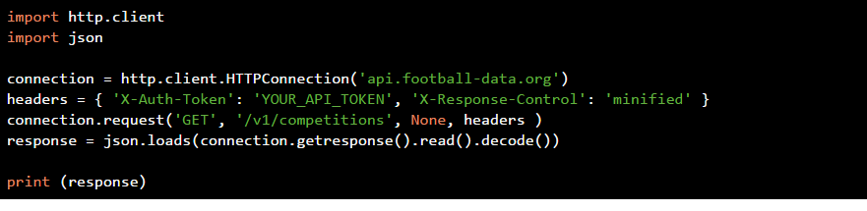

This picture displays an example of the usage of the api of that source.